

**DAY 6 - DEPLOYMENT PREPARATION AND STAGING ENVIRONMENT SETUP**

**E-Commerce Website**

**Product: Pudding & Jelly Powders**

**Name: Umehani**

**Roll No: 00364678**

**Day/Time: Friday – 09:00 – 12:00**

**Teacher: Sir Hamzah Syed**

**Steps for Day 6:**

**Step 1: Hosting Platform Setup**

**1. Choose a Platform:**

* Use platforms like Vercel or Netlify for quick deployment.
* For advanced configurations, consider AWS or Azure.

**2. Connect Repository:**

* Link your GitHub repository to the hosting platform.
* Configure build settings and add necessary scripts for deployment.

**Step 2: Configure Environment Variables**

**1. Create a .env File:**

* Include sensitive variables like API keys and tokens.
* NEXT_PUBLIC_SANITY_PROJECT_ID=your_project_id
* NEXT_PUBLIC_SANITY_DATASET=production
* API_KEY=your_api_key

**2. Upload Variables to Hosting Platform:**

* Use the hosting platform’s dashboard to securely add environment variables.

**Step 3: Deploy to Staging**

**1. Deploy Application:**

* Deploy the application to a staging environment through the hosting platform.

**2. Validate Deployment:**

* Ensure the build process completes without errors.
* Verify basic functionality in the staging environment.

**Step 4: Staging Environment Testing**

**1. Testing Types:**

* Functional Testing: Verify all features, such as product listing, search, and cart operations.
* Performance Testing: Use Lighthouse or GTmetrix to analyze speed and responsiveness.
* Security Testing: Validate input fields, HTTPS usage, and secure API communications.

**2. Test Case Reporting:**

* Document all test cases in a CSV file with fields like Test Case ID,
* Description, Steps, Expected Result, Actual Result, Status, and Remarks.

For example:

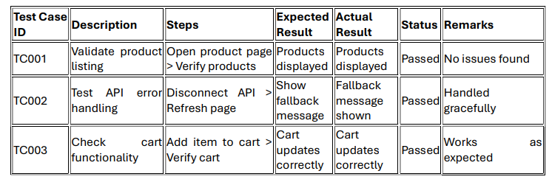

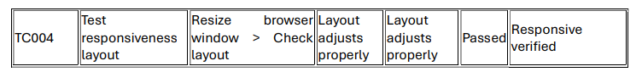

**3. Performance Testing:**

* Submit a performance report generated by tools like Lighthouse in your

GitHub repository.

**Step 5: Documentation Updates**

**1. Create README.md:**

* Summarize all project activities, including deployment steps and test case results.

**2. Organize Project Files:**

* Ensure all files from Days 1 to 6 are in a structured folder hierarch

**Checklist for Day 6:**

* Deployment Preparation:

✔ ✘

* Staging Environment Testing:

✔ ✘

* Documentation:

✔ ✘

* Form Submission:

✔ ✘

* Final Review:

✔✘